Salem United Church of Christ Moorestown
Church Office (610) 759-1652 – www.salemuccbathpa.org
Pastor Kaye Lentz, (610)217-0041, email:SalemPastor2218@yahoo.com
Lisa Abruzzese, Organist/Choir Director, (610) 217-4234
Ministers of the Church – Every Member of Salem UCC
May 24, 2020 – Ascension Sunday; Seventh Sunday of Easter.

Music
Welcome to Virtual Worship
Prelude
Call to Worship
One: Clap your hands, all you peoples; shout to God with loud songs of joy.
All: For the Lord, the most high, is awesome, a great king over all the earth
One: Sing praises to God, sing praises. Sing praises to our King.
All: For God is king of all the earth, sing praises with a psalm
One: God is king over the nations; God sits on his holy throne.
All: The princes of the peoples gather as the people of the God of Abraham. For the shields of the earth belong to God; he is highly exalted.

Opening Prayer
All: God of incredible surprises, as we gaze into the clouds, remind us that we are standing on holy ground. Place our feet on the pathways of peace and hope. Draw our attention from the vision of the Lord rising to the heavens to be with you and help us to focus on the ministries that you would have us do. Keep us ready and willing always to serve you all our days. Amen.
Music – Hymn #654 “Holy Ground” (sing twice)
Prayer of Confession
All: Forgiving and gracious God, you have called us to be the church, to live out our Resurrection faith. You have asked us to place our trust in you and to bring to all the good news of your saving love. But we struggle and fail to do this. We have given our faith a back seat to the troubles of the world and to the stresses in our own life. We look for the quick and easy answers. Forgive us for the smallness of our faith. You, who raised Christ from the dead, have promised to raise our spirits and bring us to new life. You have done this and yet, we do not see what power we have with our faith in you. Help us to see. Clear our spirits of the clutter of everyday living. Open our eyes, hearts and mind to your word and your love. Challenge us to move in directions of peace and hope for all people. These things we pray in the name of our risen Lord. Amen.

Assurance of Forgiveness
One: Who is in a position to condemn? Only Christ, and Christ died for us, Christ rose for us, Christ reigns in power for us, Christ prays for us. In the midst of doubt and darkness, the light of God is shining in you, on you, and through you. In Jesus Christ we are forgiven!
All: Thanks be to God!

Passing of the Peace

Children’s Message - Vicki Troxell

Scripture Lesson
Acts 1:1-11 – Jesus taken up to heaven
Ephesians 1:15-23 – Thanksgiving and Prayer
Luke 24:44-53 – The Ascension of Jesus

One: This is the word of the Lord
ALL: Thanks be to God

Today’s Message

Solo – “You’ll Never Walk Alone” - Bruce Roth

Offering – God provides us with so much more than love and faith. All that we have, all that we give already belongs to God. Consider now ways that we can be thankful for our blessings and all that we have. I invite you to consider ways to give your time and talents in new ways in this time of social distancing. I also ask you to consider how you will offer your tithes and offerings to support the ministry of our church at this time as well – some options are: on-line giving available through our website or your smartphone, mailing in your offering, or set aside your offering each week until we can meet again.

Prayer & The Lord’s Prayer

Music – Hymn #748 “Lord, Dismiss Us with Your Blessing”

Benediction

Brothers and sisters, the same power that raised Jesus Christ from the dead and seated him in the place of honor at God’s right hand, is at work in each of us who believe!

See what power our faith has. Go with confidence and peace knowing that God’s presence and power go with you. Amen

Three Fold Amen

Postlude

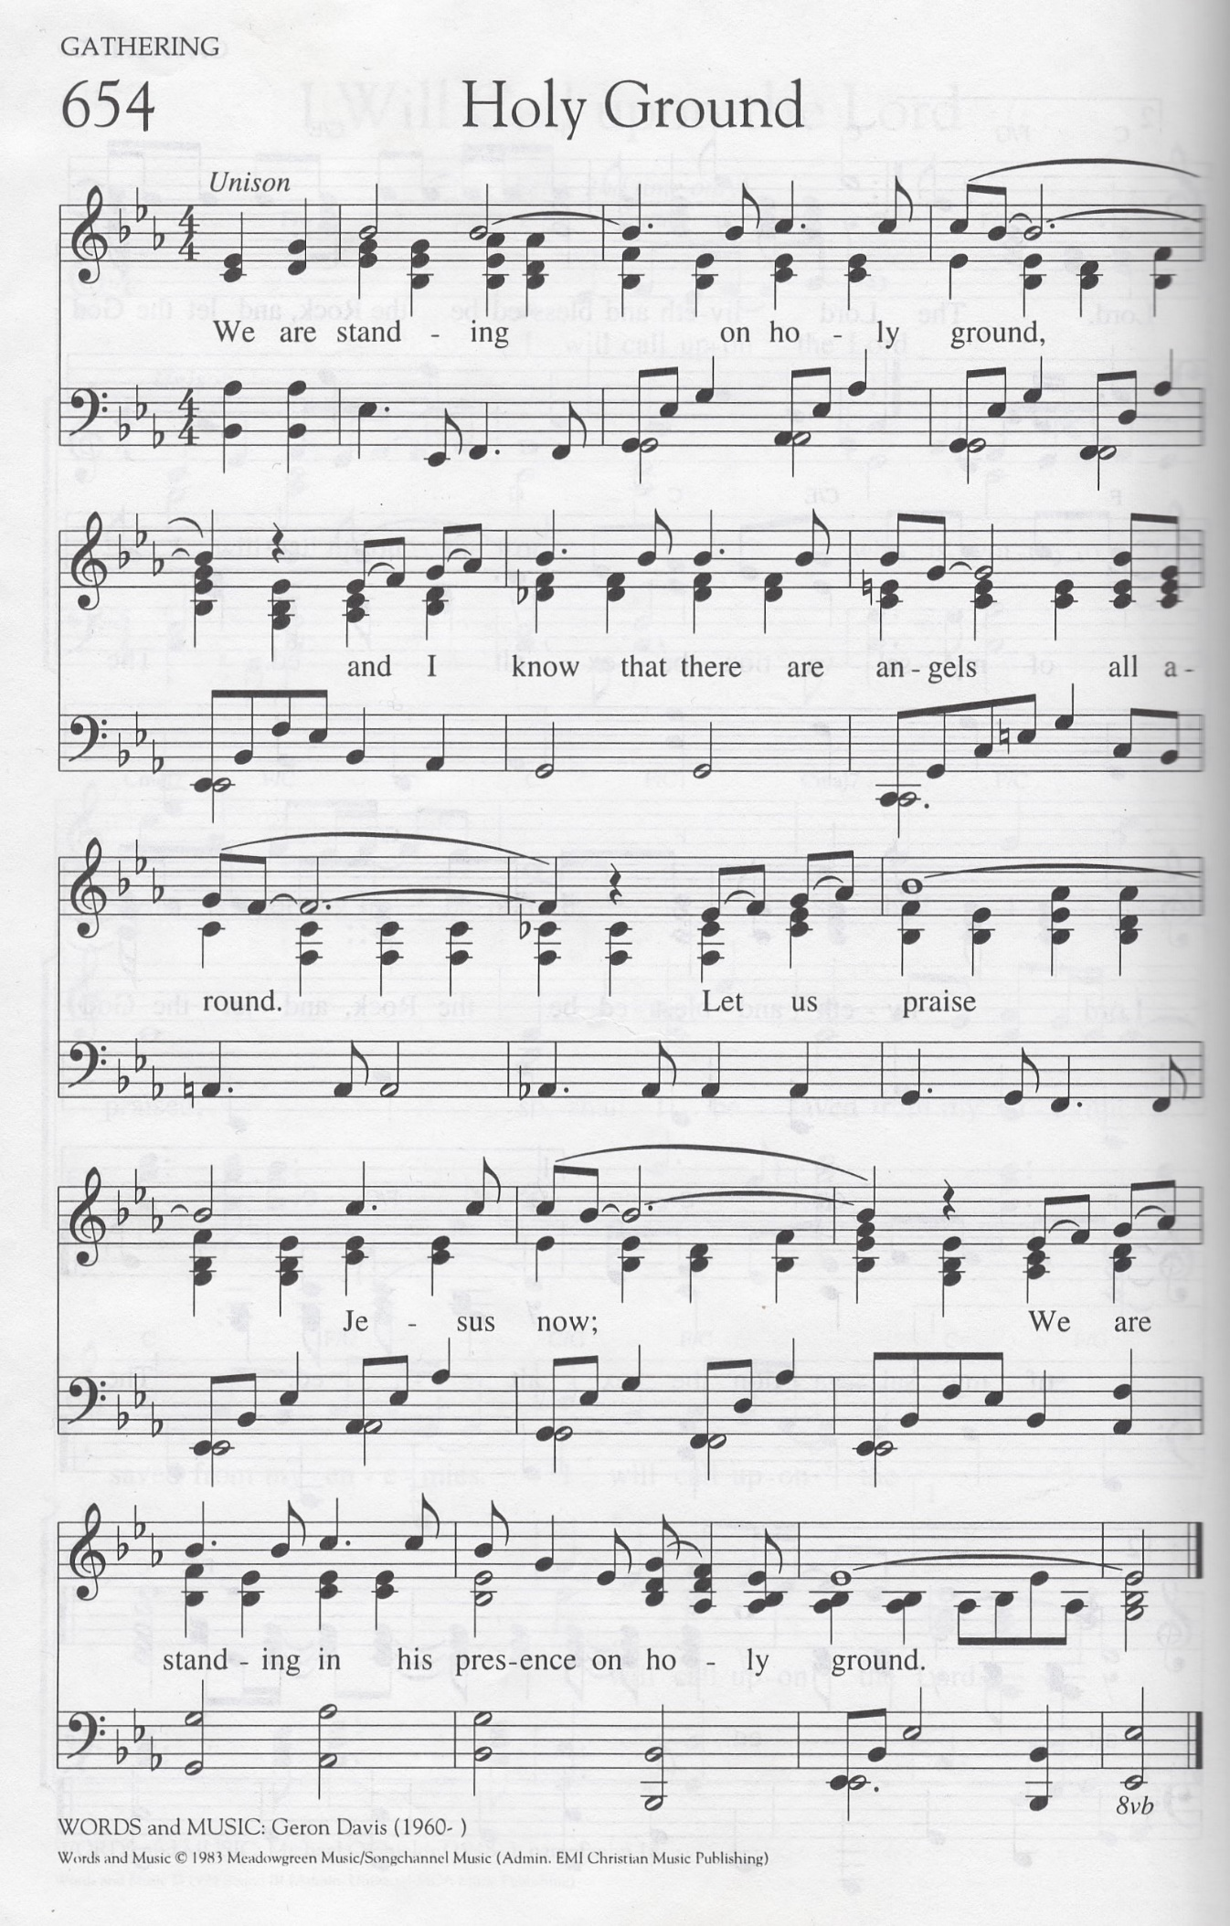

You'll Never Walk Alone

When you walk through a storm
Hold your head up high
And don't be afraid of the dark
At the end of a storm
There's a golden sky
And the sweet silver song of a lark
Walk on through the wind
Walk on through the rain
Though your dreams be tossed and blown
Walk on, walk on
With hope in your heart
And you'll never walk alone
You'll never walk alone
Walk on, walk on
With hope in your heart
And you'll never walk alone
You'll never walk alone

